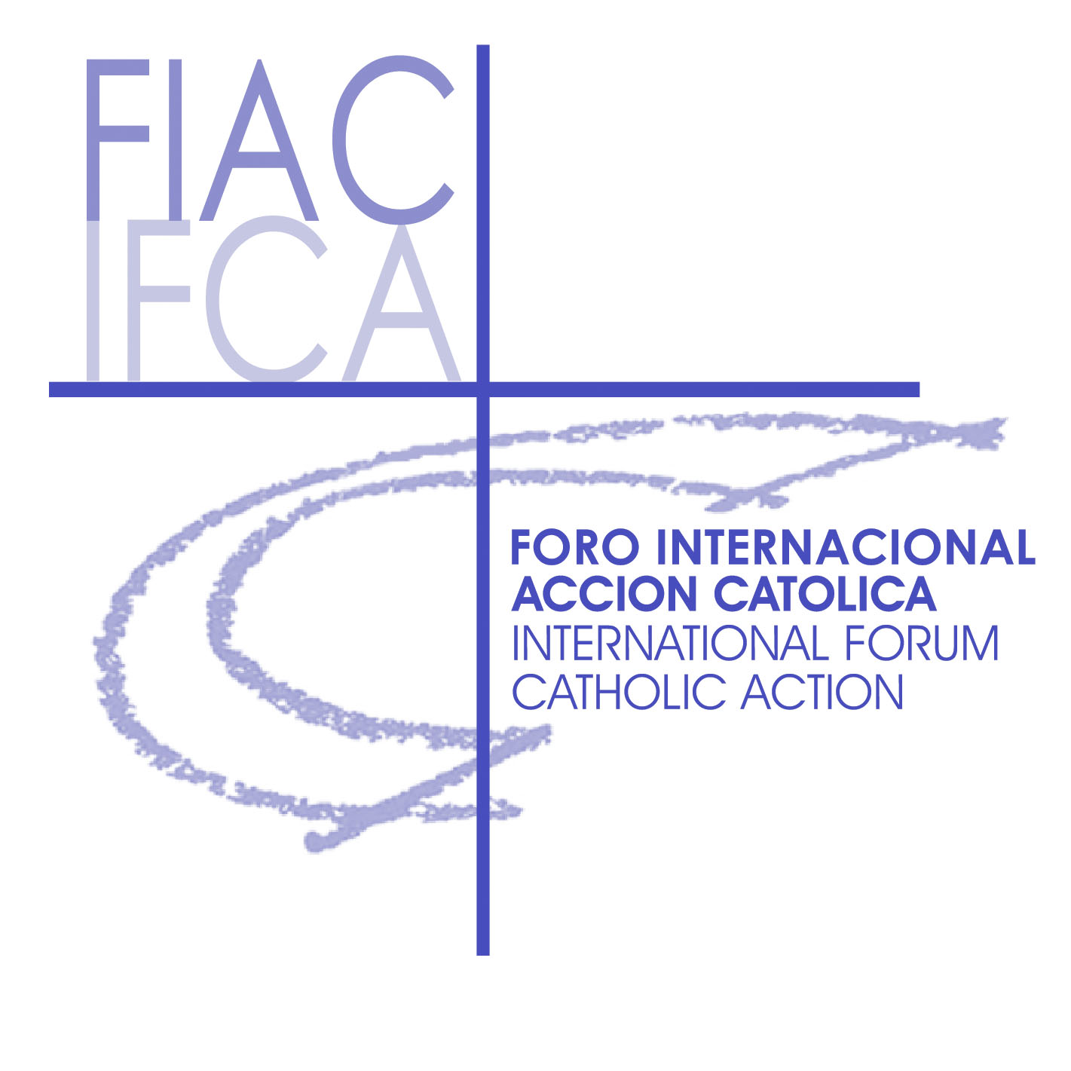
IFCA YOUTH COORDINATION

In collaboration with the LATIN PATRIARCHATE
CUSTODY OF THE HOLY LAND

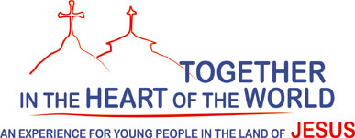

Residential and itinerary formation proposal with activities in parishes 2010-2012
First session 27 November – 13 December 2010
Definite Programme
Saturday 27 November (Bethlehem)
Arrivals and allocation of rooms in Bethlehem
11.30 Solemn entrance of the Custodian to Bethlehem and Scouts Parade
13.45 Solemn Vespers - Saint Catherine Parish
15.30 Readings of the Office - Saint Catherine

Sunday 28 November (Bethlehem)
First Sunday in Advent
Feast of Saint Catherine of Alexandria, patron saint of the Parish
9.00 Solemn Mass in the Parish
Lunch at CAB
18.00 Presentation of the Course and of the participants

Monday 29 November (Bethlehem)
8.30 Morning prayer and presentation of the day's programme
9.00-13.00 Three talks on biblical Geography by Fr. Pietro Kaswalder OFM
(Lecturer in Old Testament Exegesis and in Biblical Geography)
16.00 Meeting open to members of the Parish
Address of welcome by Fr. Marwan Di’Des OFM, Parish Priest
Middle East SYNOD /1 H.E. Mgr. William Shomali
The Synod of the Church of the Middle East, the Message to the People of God
Middle East SYNOD /2, from Bethlehem to the Synod, from the Synod to Bethlehem
With first hand experiences by Fr. Giorgio Gianazza SDB, Fr. Peter Du Brul SJ, Husam Wahhab.

18.00 Meeting with young people from the Bet Jala Parish and with the Parish Priest
Holy Mass (Fr. Fabio) Dinner
Visit to the Seminary

Tuesday 30 November (Bethlehem)
Saint Andrew
7.30 Morning prayer and presentation of the day's programme
8.00-11.00 Talks on Bible History (New Testament period)
By Fr. Eugenio Alliata OFM (lecturer in Archeology)
12.30 University of Hebron (Prof. Sami Basha)
The Shepherds’ Field (guide)
Meeting with young people from the Beit Sahour Parish and with the Parish Priest
Responsible for Youth Ministry - Holy Mass ( Fr. Tommaso)

Wednesday 1 December (Bethlehem)
Blessed Charles de Foucauld
7.30 Holy Mass at the Nativity Grotto
Visit to the Basilica
10.00-12.30 Free time – individual study
13.00 Visit to the Bethlehem catholic University – Fr. Jamal Khader
Meeting wit Fr. Jamal and students
16.00-17.30 Talk about the Prevailing conflict and Christians’ commitment in the world
Prof. Jacqueline Sfeir – Prof. Sami Basha

Thursday 2 December (Bethlehem)
6.00 Departure for Jerusalem (New Gate)
8.00 HOLY MASS at the Franciscan Chapel of the Blessed Sacrament in the Holy Sepulchre
Church (Fr. David Neuhaus SJ)
Visit to the Holy Sepulchre – Guide: Fr. Giovanni Loche OFM (lecturer in Argheology)
The Cenacle – the Dormition – the Armenian Quarters
Lunch in the Parish
14.00 Vicariate for Hebrew speaking Catholics
Fr. David Neuhaus SJ – Our roots are in the Holy Land - the Middle East
- Meeting at Effata
19.00 Prayer at the CARMEL (Blessed Mary of the Crucufied Jesus Miriam Baouardy)

Friday 3 December (Bethlehem)
Saint Francis Xavier
7.00 Departure for Jerusalem – Mount of Olives,
The Our Father site
10.00 Holy Mass at Dominus Flevit (Fr. Laurent)
Gethsemane the Pool at Bethesda (S.Anne)
Stop at the IV Station (adoration)
15.00 VIA CRUCIS with the Friars of the Custody of the Holy Land
16.30 Meeting with Fr. Pier Battista Pizzaballa OFM Custodian of the Holy Land in the Custody
Our Salviour Parish (meeting with young people)
Shabbat - Western Wall -
20.00 Beit Hanina Pizzeria
Return to Bethlehem

Saturday 4 December (Bethlehem)
Saint John of Damascus
9.00 Eucharistic Celebration in the Milk Grotto (Fr. Tommaso)
Free morning
13.00 Caritas Baby Hospital
Meeting with nuns of Byzantine rite Visit to Caritas Baby Hospital
FCIM nuns - Aida Refugee Camp Nuns
- Meeting with young people from the parish, dinner together and farewell

Sunday 5 December (Nazareth)
  - Holy Mass at Ramallah parish
Meeting with the Family of the Annunciation Ain Arik
Stop in the Desert
  - Arrival in Nazareth
Accomodation and dinner with host families

Monday 6 December (Nazareth)
  - Morning prayer and presentation of the day's programme
9.00-11.00 Meeting with H.E. Mgr. Marcuzzo (1)
The local Church in the Holy Land today
  - Introductory information about Galilee (1) Fr. Massimo Luca
13.00 Holy Mass (Fr. Fabio) and visit to the Opera Don Guanello
15.00 Visit to Holy Places in Nazareth with Fr. Massimo

Tuesday 7 December (Nazareth)
8.00 Excursion in Galilee: Mount Tabor with Fr. Massimo Luca
11.00 Holy Mass (Fr. Tommaso)
12.00 Lunch and return to Nazareth
15.30 Introductory information about Galilee (2) by Fr. Massimo Luca
17.00-1900 Meeting with H.E. Mgr. Marcuzzo (2)
The local Church in the Holy Land: history, theology, saints
20.30 Rosary in the Annunciation Basilica being the vigil of the Immaculate Conception

Wednesday 8 December (Nazareth)
FEAST OR THE IMMACULATE CONCEPTION
8.00 Excursion in Galilee: with Fr. Massimo Luca
Mount of the Beatitudes Cafarnao and Lake of Tiberias
12.30 By boat on the lake
14.00 Dinner at the Living Water
15.00 Visit to the site of the Multiplication of Bread
16.00 Holy Mass at St Peter’s Primacy ( Fr. David) – Return to Nazareth
18.00 Meeting at the places where Blessed Charles de Foucauld lived
with the Jesus Caritas Community

Thursday 9 December (Nazareth)
8.00 Excursion to the Golan Heights – Dan Banias with Fr. Massimo Luca
15.30 Cana: Holy Mass A. Laurent, visit
17.00 Free time
20.30 Eucharistic adoration at the Annunciation Basilica
21.30 Meeting with Fr. Amjad Sabbara OFM parish priest of the Annunciation Parish
“Lay people’s o-responsibility in the parish” and the parish pastoral work

FRIDAY 10 December (Nazareth)
9.00 Departure for the Mount Carmel
Visit - Holy Mass (Fr.Fabio) - Lunch at Stella Maris
Visit to the Carmel and to the Italian Hospital
15.30 Meeting with young people in the parish at Haifa
Return to Nazareth
  - Meeting with a group of young students of Italian at the Benedict XVI Centre
ASSOCIATIVE EVENING at Casa Nova – presentations of CAs

Saturday 11 December (Nazareth)
Retreat Day
      - Biblical introduction in the place where Charles de Foucauld lived
(Fr. Marco - Jesus Caritas community)
  - Departure for the Lake
  - Departure for the parish at Mukeble
17.00 Mass in the Parish (Fr. Marco – Don Guanella)
20.30 Torchlight procession to the Annunciation Basilica

Sunday 12 December (Nazareth)
Third Sunday in Advent
10.00 Holy Mass in the Annunciation Parish in Nazareth
11.30 Departure for Emmaus wit H.E. Mgr. Marcuzzo
visita to Cesarea Marittima and tel Aviv bus
16.00 Emmaus Nicopolis
19.30 Meeting and feast at latin parish in Nazreth
with the youths and fr. Amjad Sabbara – parosh priest

Monday 13th December
During the night Departures for Burundi Romania
9.00 Holy Mass in the annunciation Grottp
10.00 Departures to the airport: Italy Myanmar Argentina and a stop in Haifa – latin Parish
(participants from the Holy Land)

